Evolution of Comic Strips
Name
Institution
Date

Evolution of Comic Strips
Comic strips got well established in the United States in the late 18th century. They inspire our imagination, speak our thoughts, transcend our expectations, move us, and, most importantly, make us laugh. They have formed part of the American culture and have been critical in influencing American history through political criticism and the promotion of superhero figures (Dukut, 2017). Some comic strips have existed for decades and have evolved significantly over the years in terms of the visual aspects, dialogue, and characters. The following is a discussion of how the three comic strips; For Better or for Worse, The Peanuts, and Family Circus have evolved over the years.
- For Better or for Worse
The comic strip, For Better or For Worse, was created by Lynn Johnston and originally ran from 1979 to 2008. The story runs around the Patterson family (John, Elly, Michael, and Elizabeth) and later covers close friends and relatives from a fictitious town, Milborough, in Toronto. The comic strip is currently running in papers as returns.
The original comic strips starting 1979 were published in papers using black and white drawings and dialogue because colored graphics were nonexistent back then. Fans enjoyed the black and white visual comic strips due to a lack of an alternative. The creation of black and white comic strips posed a lot of challenges for authors, especially while trying to express and distinguishing object/symbols within the strips. It was equally difficult for consumers sometimes to tell some of the objects in the comic without color and other times created a gap between the artist and the fans. The captions or text boxes are explicit and clearly present the narration. However, the later invention of colored graphics improved visuals immensely and made it easier to create and understand comic strips by authors and consumers, respectively. Though the content remained relatively unchanged, color graphics improved the understanding of the relationships between images and texts. Since comic strips happen in real-time, the author is keen also to have her characters aging by changing their physical appearances.
The dialogue in For Better or For Worse has evolved also evolved over the decades. As a young family, the conversations between Patterson’s at the beginning are like that of any other typical young family. Such discussions are displayed by the speech bubbles and symbols. According to Dukut (2017), when writing dialogue for comics, it is essential to be realistic. Johnston is very realistic with his dialogue conversations between characters. The strips begin when Michael and Elizabeth are toddlers, and the dialogue between them and their parents has evolved from being guided, directed and advised across their childhood to a different conversation when Michael and Elizabeth are adults married. In another perspective, after ending production of the comic in 2008, there was an attempt to reintroduce the comic strips with altered dialogue, which lasted on two years before settling on returns using original dialogue.
The character's evolution was critical in the popularity of the comic strips. First of all, the Patterson family, who are the main characters, evolved throughout the comic strips. The comic strip begins in 1979 when they are a young family with Michael and Elizabeth as toddlers. Later April is born, and by the end of the comic strips in 2008, Michael and Elizabeth are grown-ups and married. Their parents are also aged. Besides, throughout the comic, there is noted the evolution of characters where new characters come into scenes or disappear. A few examples of new characters include Michael's childhood girlfriend, Deanna Sobinski, whom he marries later, Antony Caine (Elizabeth friend and later husband), Lawrence, Françoise, Robin, James Allen, Farley the pet dog, etc. The character that exited the comic strips includes Farley, who died after rescuing April from drawing in a pool and Michael Boncoeur.
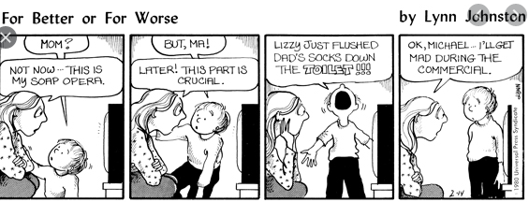
Early black and white comic strips
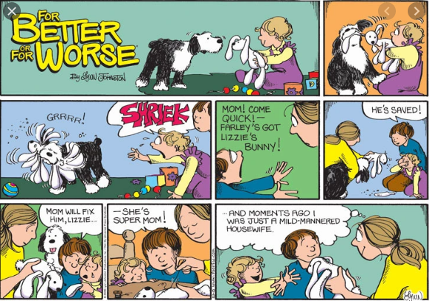
Colored comic strips
- The Peanut
The syndicate comic strip was written by Charles Schulz and appeared on daily papers and on Sunday strip. It ran from October 1950 to February 2000 and had since been continuing as returns. It is among the most popular comic strips in the world, which saw the publishing of 17,897 strips becoming the longest story narrated by a human. By the death of Schulz in 2000, the comic strip appeared in approximately 2,600 papers across 75 countries. The comic strip is centered on the social life of young children with adults existing but not appearing to promote the plot of the comic. Charlie Brown is the main character and is portrayed to lack confidence, meek, and nervous while Lucy is his best friend.
Just like the For Better or For Worse, The Peanuts started as a black and white drawn cartoon sequence published in local newspapers in 1950. The cartoon sequence visuals consisted of cartoon characters with speech balloons and background in papers. Initially, The Peanuts started as a daily comic strip with a four strip panel. The panels showed Charlie Brown with two young children, walking while talking. The Sunday strip contained was published in half a page. The background was not mostly used by Schulz's in the strips, and when he did, he used frazzled lines that had a psychological or a fraught appearance. Lack of background allows readers to focus on the more relevant content like the speech balloons (Singsen, 2017). While the early strips resemble the later ones, some significant visual differences can be noted. Early strips were simpler, cleaner, and sleeker with lined backgrounds, and characters were squatting. Charlie's head resembled a rugby ball shape while other kids' heads were rounded.
The dialogue of the comic strips kept evolving from the initial strip in 1950 until 2000 though the intention remained the same. The peanuts is pure humor, and its characters express it candidly, especially towards Charlie Brown in different settings. Other characters view him as a failure, but although he suffers from an inferiority complex, he is determined to succeed, as shown by his stubbornness and undying persistence. Though he can't make a kite or win a ball game that doesn't put him down or allow him to quit while his being reflective, considerate, and decent, allow him to socialize with other children. Therefore, the dialogue of the plot for the fifty-year-old comic surrounds his consistent failure and his optimism that makes him think he can boost his sense of self-worth. Schulz used every satirical context possible by exploring as many topics as possible, for instance, playing baseball with a dog and three girls in a team, the Vietnam War, Dress code, religion, etc. The prevailing political and economic conditions influenced his strips.
A more significant evolution is witnessed in the characters of The Peanut. This is mainly expressed by the number of characters who join later to break boredom improve the diversity of the content. Snoopy, Charlie Brown and his dog form the major characters of the strip. However, other characters did not appear in the comic until later. Those who became regulars include; Violet who joined in February 1951, Schroeder in May 1951, Linus in September 1952, Pig-Pen joined in July 1954, Sally appeared in August 1959, Frieda in March 1961, Patty in August 1966, Franklin joined in July 1968, Woodstock appeared in 1967 but was named later in June 1970, Mercy appeared in July 1971 and Rerun was introduced in March 1973.
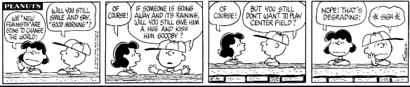
The peanut debut comic strip October 2, 1950
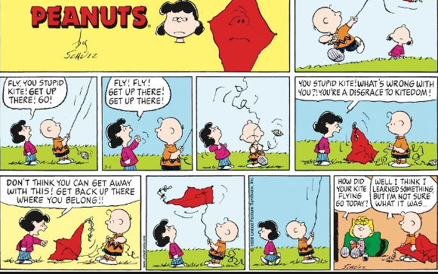
Colored March 1998 comic strip
- Family Circus
Family Circus was originally titled The Family Circle and Family-Go-Round and was written by Bil Keane until 2011 when he passed on. Currently, it is written by his son Jeff Keane. The comic strip was first published in February 1960 and is still in production to date. It is among the most syndicated cartoon publishing by appearing in about 1,500 newspapers wild wide. The comic strips combine sarcasm and family life. The main characters include an unnamed family though later in 2013, August 26, in a cartoon publishing the names Keane and Carne indicate a reference to the writer's real family. Therefore, the comic strip is a fictionalization of Bil Kean's family that includes Thelma (his wife), their four children, Billy, Jeffy, Dolly and P.J, two dogs, and Bil's mother and late father who appears in spirit.
The visuals of the comic strip include a conspicuous large circle-like panel, which initially led to the title Family Circle. The panel has two major divisions. Inside the large circle is where the author, Bil, draws the cartoons representing one or more characters depending on the context and topic he chose with a speech balloon. Outside the circle, on the bottom side, is where Bil writes the message or caption. The author writes the date on the immediate left above the message and his signature on the opposite end. Initially didn't have a much-pronounced background; instead, he left it blank or drawn lines. However, colored strips show a much more expressive background and bring out a better understanding of the identities and relationships among characters and the environment. For instance, it is a common feature for Bil to use a thick dotted line to illustrate the character's path to a house or way through the neighborhood.
The dialogue revolves around their family life in Scottsdale, Arizona. The characters seem to frequent an ice cream parlor called the Sugar Bowl. The content is mainly based on the encounters of an ordinary family, and therefore the dialogues are sporadic and consistent with family contexts. The topics range from education, health, vacation, religion, weather, etc. Having a variety of contexts for topics has allowed Bil to flourish and stay relevant to the fans. The writer, for example, is portrayed to harbor Christian themes and imagery, which lead to Jeffy to daydream about Jesus visiting a grocery store in one of the strips. In other strips, the children are shown to attend catholic schools and churches. According to Singsen,( 2017), personal experiences also contributed to the evolution of the dialogue, for instance, Bil's boyhood snow experience in Pennsylvania inspired a strip where his family is shown enjoying snow around their home.
Bil's family was the main character since the beginning of the comic strips. Since the first strip in 1960, the characters have not aged except for P.J, who was born in August 1962 and has grown to about one year though he rarely speaks. The other characters later introduced to the comic strip include Florence (Bil's mother commonly referred to as Grandma in strips) and Al (Bil's father, though dead he appears as spirit). On January 26, 1970, the family introduced three pets, two dogs (Barfy and Sam), and a cat named Kittycat. Moreover, other characters coming into the comic strips include Morrie Turner, who is Billy's playmate, and Bil's boss called Horton.
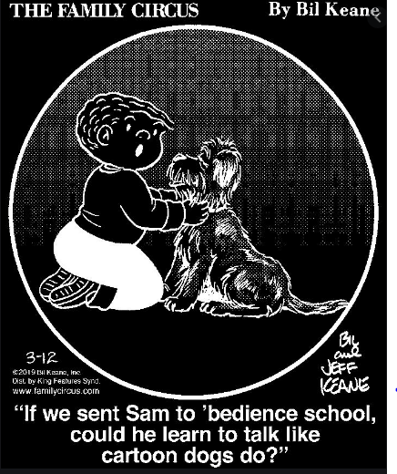
Early black and white comic stripe
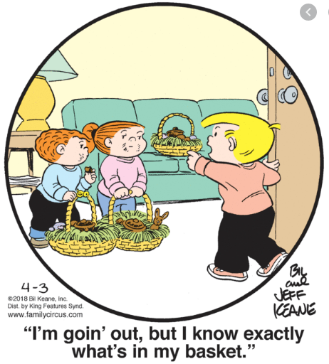
Colored recent comic strip by Jeff Keane

References
Dukut, E. M. (2017). Comic Strips: A Reflection of the American Spirit. Celt: A Journal of Culture, English Language Teaching & Literature, 1(1), 63-77.
Family Circus.com. (February 3, 2020). Retrieved from https://www.comicskingdom.com/family-circus
For better or for worse. Com. (February 3, 2020). Retrieved from https://www.fborfw.com/
Singsen, D. (2017). Critical perspectives on mainstream, groundlevel, and alternative comics in The Comics Journal, 1977 to 1996. Journal of Graphic Novels and Comics, 8(2), 156-172.
The Peanut.com. February 3, 2020. Retrieved from https://www.peanuts.com/

